DEPLOYMENT 1

WHAT WENT WRONG:

* Creating the folders in the repository
  + I clicked around until I figured it out. I had to open the folders individually and add the contents to my repository
* Jenkins
  + Rewatched the video to remember how to create my credentials
* Tyrone helped me with the issue below. I was trying to figure out a lot at once and forgot to document what the issue actually was here and how to fix it. I believe it had something to do with my credentials. Once this was fixed I was able to run Jenkins successfully



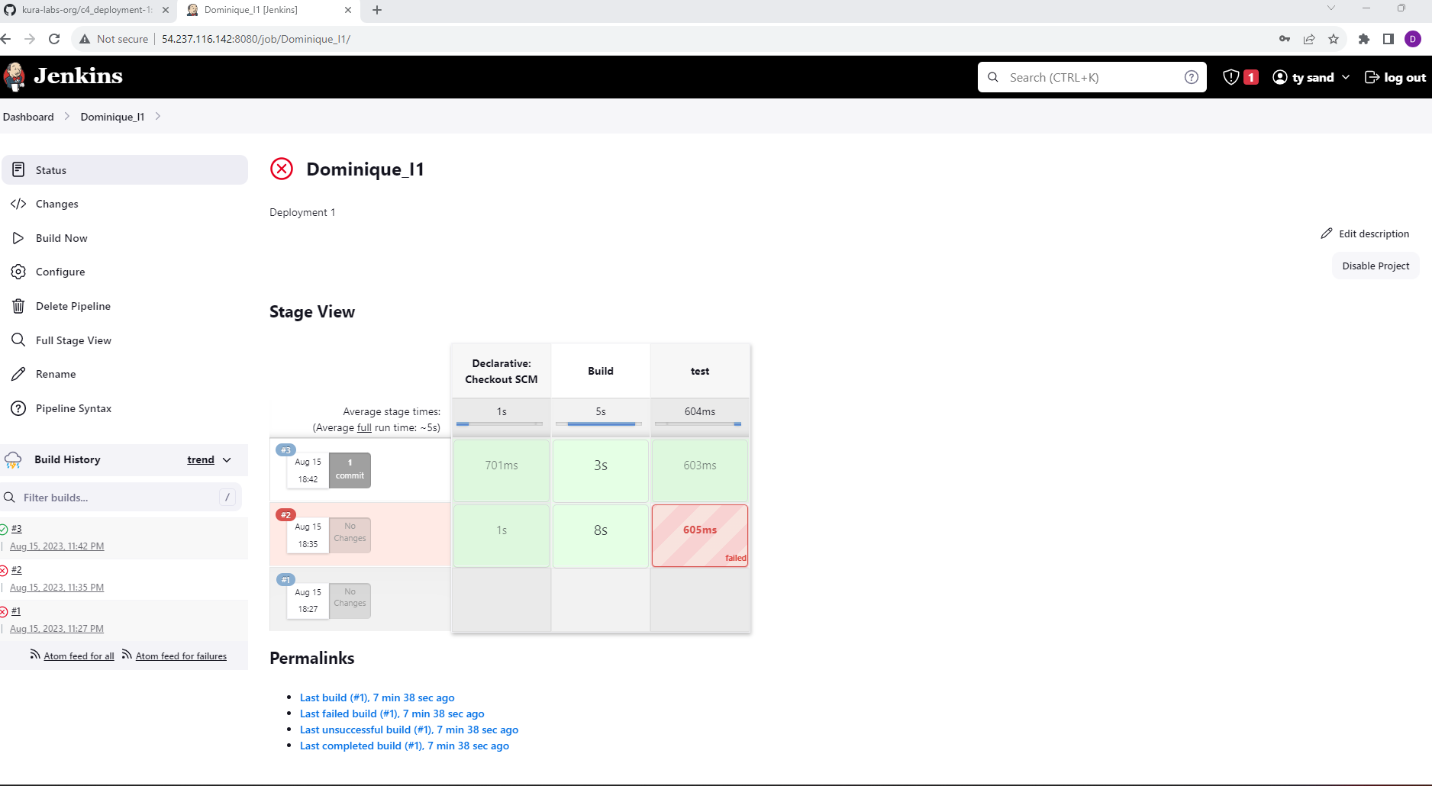

* I had issues with EB at first because my zipped files weren’t saved properly. Nicole and Kevin helped me to resave my zipped files and reupload. From there, I followed the Scribe directions and was able to run EB successfully: [Url-shortener-env.eba-9pmrmvp8.us-east-1.elasticbeanstalk.com](http://url-shortener-env.eba-9pmrmvp8.us-east-1.elasticbeanstalk.com/)
  + URL SHORTENER: <http://url-shortener-env.eba-9pmrmvp8.us-east-1.elasticbeanstalk.com/Dominique_I>

